Software Requirements Specification
for
Health Watch
Web Application

Version 1.2
Author, Tabish Habib
Table of Contents
Table of Contents ii
Revision History ii
1. Introduction 1
1.1 Purpose 1
1.2 Product Scope 1
1.3 Definitions, acronyms, and abbreviations 1
1.4 References 1
2. Overall Description 3
2.1 Product Perspective 3
2.2 Product Functions 3
2.3 User Classes and Characteristics 4
2.4 Operating Environment 5
2.5 Design and Implementation Constraints 5
2.6 Assumptions and Dependencies 5
3. External Interface Requirements 6
3.1 User Interfaces 6
3.2 Hardware Interfaces 9
3.3 Software Interfaces 10
3.4 Communications Interfaces 10
4. Functional Requirements 11
4.1 Use Cases 11
4.2 Sequence Diagrams 14
5. Other Nonfunctional Requirements 18
5.1 Usability 18
5.2 Performance Requirements 18
5.3 Safety Requirements 18
5.4 Security Requirements 18
5.5 Software Quality Attributes 19
6. Appendix A: Analysis Models 20
6.1 ERD (Entity Relationship Diagram) 20

Revision History
Name | Date | Reason For Changes | Version
Tabish | 2023 | Introduction & Overall Description updated | 1.0
Tabish | 2023 | External Interface Requirements and Other Nonfunctional Requirements added | 1.1
Tabish | 2023 | Functional Requirement & Analysis Models added | 1.2

Introduction

Purpose
This document outlines requirements of different categories associated with the Health Watch system for the stakeholders to understand the purpose and features of the system.

Product Scope
The Health Watch system is a health monitoring web application that enables its authenticated users to record and analyze Blood Pressure, Blood Glucose, Pulse Rates and Oxygen Saturation measurements/readings taken from respective devices.
Data can be fed into the system from which statistics for analysis are generated in the form of Tables, Graphs, summaries, and printable reports.
This system is aimed to provide 2 primary benefits. Firstly, it will allow users with health vulnerabilities to keep a statistical watch on their health. Secondly, printable reports from the system will assist doctors in the efficient diagnosis and management of diseases.

Definitions, acronyms, and abbreviations
Blood Pressure (BP) | Pressure of circulating blood against the walls of blood vessels
Blood Glucose | Amount of sugar found in blood
Pulse Rate | No of times the heart beats in one minute
Oxygen Saturation | Percentage of oxygen in the blood
GUI | Graphical User Interface, pages of website or web application
Authenticated | Verified to have a valid user id and password
OTP | One Time Password, used for authentication
W3C | World Wide Consortium, a body that maintains international standards for Internet
HTML5 | Hyper Text Markup Language version 5, a language to define Webpages
SMS Gateway | A system that forwards text messages as an SMS to the destination mobile number
External | Not part of the system under consideration in this SRS
oAuth | A mechanism to get access to protected resources of a system
Token | Secret value generated by the oAuth mechanism
Health Parameters | In context of this SRS, refers to Blood Pressure, Blood Glucose, Pulse Rate & Oxygen Saturation
Back-end | Private area of system where business logic resides
Pwd | Password
HTTPS | Hypertext Transfer Protocol Secure, for encrypted communication

References
The University of Adelaide, 2018, Harvard Referencing Guide, The University of Adelaide, viewed 16 Feb 2022,
<https://www.adelaide.edu.au/writingcentre/sites/default/files/docs/harvard-referencing-guide.pdf>

Himmelfarb Health Sciences Library, 2022, Harvard Citation Style: All Examples, Himmelfarb Health Sciences Library, viewed 16 Feb 2022, <https://guides.himmelfarb.gwu.edu/harvard_citation/all-examples>

Dalhousie University, n.d., IEEE Software Requirements Specification Template, Dalhousie University, viewed 16 Feb 2022, <https://web.cs.dal.ca/~hawkey/3130/srs_template-ieee.doc>
ResearchGate, 2011, Software Requirements Specification (SRS) for the <Nodes Portal Toolkit (NPT), ResearchGate, viewed 16 Feb 2022, <https://www.researchgate.net/publication/265397639_Software_Requirements_Specification_SRS_for_the_Nodes_Portal_Toolkit_NPT>

Michigan State University, n.d., Software Requirements Specification (SRS) Book E-Commerce System (BECS), Michigan State University, viewed 16 Feb 2022, <https://www.cse.msu.edu/~chengb/RE-491/Papers/SRS-BECS-2007.pdf>

Kate Moran, 2015, n.d., The Characteristics of Minimalism in Web Design, NN/g Nielsen Norman Group, viewed 25 Mar 2022, <https://www.nngroup.com/articles/characteristics-minimalism/>

World Health Organization, 2021, Hypertension, World Health Organization, viewed 25 Feb 2022,
<https://www.who.int/news-room/fact-sheets/detail/hypertension>

Mathew Hoffman, 2020, High Blood Sugar, Diabetes, and Your Body, WebMD, viewed 25 Feb 2022,
<https://www.webmd.com/diabetes/how-sugar-affects-diabetes>

oAuth.com, n.d., Bearer Tokens, oAuth.com, viewed 28 Feb 2022, <https://www.oauth.com/oauth2-servers/differences-between-oauth-1-2/bearer-tokens/>

twilio, n.d., One-Time Passcode Verification (OTP), twilio, viewed 28 Feb 2022, <https://www.twilio.com/code-exchange/one-time-passcode-verification-otp>

twilio, n.d., Sending Messages, twilio, viewed 1 Mar 2022, <https://www.twilio.com/docs/sms/send-messages>

smartdraw, n.d., Sequence Diagram, smartdraw, viewed 1 Mar 2022, <https://www.smartdraw.com/sequence-diagram/>

Patrycja Dybka, 2016, Crow’s Foot Notation, Vertabelo, viewed 1 Mar 2022, <https://vertabelo.com/blog/crow-s-foot-notation/>

Jiathong, 2019, HTTP vs HTTPS: The Difference And Everything You Need To Know, SEO Presser, viewed 1 Mar 2022,
<https://seopressor.com/blog/http-vs-https/>

Satyam Singh, 2019, Common SQL Injection Attacks, Pentest-Tools Blog, viewed 1 Mar 2022, <https://pentest-tools.com/blog/sql-injection-attacks>

IBM, 2021, What is AJAX?, IBM, viewed 2 Mar 2022, <https://www.ibm.com/docs/en/rational-soft-arch/9.6.1?topic=page-asynchronous-javascript-xml-ajax-overview>

ASKINGLOT, 2020, What happens if JavaScript is disabled in a Web browser?, ASKINGLOT, viewed 2 Mar 2022, <https://www.ibm.com/docs/en/rational-soft-arch/9.6.1?topic=page-asynchronous-javascript-xml-ajax-overview>

ORACLE, n.d., Advantages of Stored Procedures, ORACLE, viewed 2 Mar 2022,
<https://docs.oracle.com/cd/F49540_01/DOC/java.815/a64686/01_intr3.htm>

Kathleen Richards, 2021, one-time password (OTP), TechTarget, viewed 2 Mar 2022,
<https://www.techtarget.com/searchsecurity/definition/one-time-password-OTP>

Vishal Sharma, n.d., What is Software Quality Assurance And Types of Testing?, Volumetree, viewed 5 Mar 2022, https://www.volumetree.com/what-is-software-quality-assurance-and-types-of-testing/

Overall Description

Product Perspective
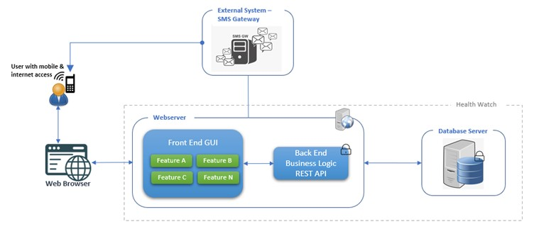
Health Watch system is conceptualized as a service-based system that will expose all its business functionalities as REST API’s. This gives the system capability to integrate with any other front-end other than the one provided with this system. To consume external services, it integrates with external systems as well. The system allows users to access all its functionalities through its webpages and is available to anyone with access to internet, modern web-browser, and a mobile phone.

Product Functions
Health Watch system offers the following functions.

- Secure Sign-Up process
  - OTP based secure Sign-Up process (Kathleen Richards 2021); OTP is sent in SMS to mobile number by the integrated external SMS Gateway

- Secure Login
  - Encrypted password storage in the system

- Password Change
  - Easy and quick password change

- Forgot Password
  - Rest forgotten password

- Logout
  - Instant session termination

- Summary Dashboard
  - 4 Graphs displaying daily average-based trends of all 4 health parameters
- Blood Pressure Dashboard
  - Summary, Graphs and Data Tables
  - Add, View, Delete Records
  - Generate Printable Report

- Blood Glucose Dashboard
  - Summary, Graphs and Data Tables
  - Add, View, Delete Records
  - Generate Printable Report

- Pulse Rate Dashboard
  - Summary, Graphs and Data Tables
  - Add, View, Delete Records
  - Generate Printable Report

- Oxygen Saturation Dashboard
  - Summary, Graphs and Data Tables
  - Add, View, Delete Records
  - Generate Printable Report

- Admin Interface for System Configuration
  - Add, Update, Delete system configuration

User Classes and Characteristics
Users of Health Watch system can be broadly classified into 4 classes by keeping in consideration the possible constraints associated with their characteristics.

Class A
User Type | Visitor, Registered User
Actions | Sign-Up or Login to use system features
Age Group | Senior age group
Frequency | High
Constraints | Difficulty in interpretation if system has complex behavior

Class B
User Type | Visitor, Registered User
Actions | Sign-Up or Login to use system features
Age Group | Young age group
Frequency | Medium to Low
Constraints | Frustration from lengthy flows that are targeted for easiness

Class C
User Type | Visitor, Registered User
Actions | Sign-Up or Login to use system features
Age Group | Young or Old age group with low level of education or computer knowledge
Frequency | Medium to Low
Constraints | Difficulty in usage if system has complex behavior

Class D
User Type | Administrator
Actions | Login to make configuration changes to the system
Age Group | Young or Old age group
Frequency | Medium
Constraints | Less control over system due to limited administrative features

Operating Environment
Client Type | All modern Web-Browsers that comply to HTML5 and W3C Standards
Recommended Client Hardware | Desktop or Laptop Computer with Mouse & Keyboard
Optional Client Hardware | Tablets, iPads, Smart Phone. (Horizontal Layout Recommended)

Design and Implementation Constraints
- Integration with an external SMS gateway is a mandatory prerequisite for the Sign-Up functionality because system generated OTP is required to be sent to the user’s mobile number for user authentication.

- System will behave abnormally if JavaScript execution is turned off on the client browser (ASKINGLOT 2020).

Assumptions and Dependencies
- It is assumed that the user has basic knowledge of browsing a web application using a keyboard and mouse attached to a personal computer.

- It is assumed that the OTP from the external SMS gateway is ideally guaranteed to be received on user’s provided mobile number. However, seldom a delay in receiving the SMS can be anticipated.

- It is assumed that the end user understands that the onus of feeding correct health records in the system is on it. Failure to do so will result in the incorrect reporting of data by the system.

- It is assumed that the host environment and infrastructure will provide high availability of the Database, and Web Server for the system to be available to its users all the time.

External Interface Requirements

User Interfaces
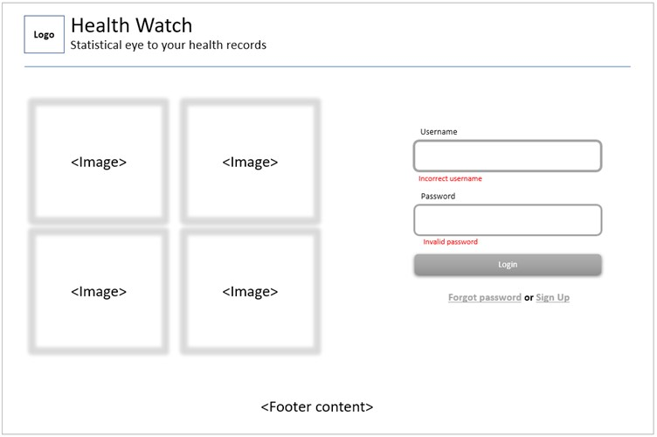
Figure 3.1.1 Wireframe for Login

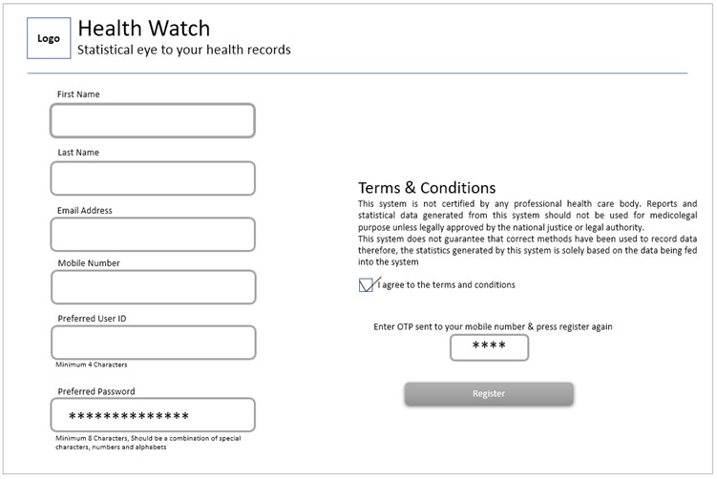
Figure 3.1.2 Wireframe for Sign-Up

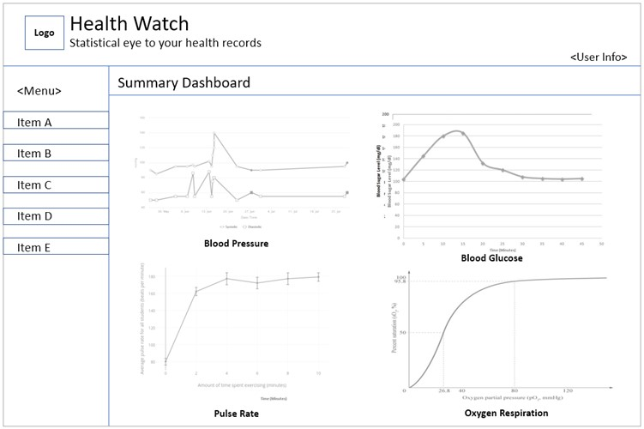
Figure 3.1.3 Wireframe for Summary Dashboard

Figure 3.1.4 Wireframe for Blood Pressure/Glucose/Pulse/Respiration Dashboards
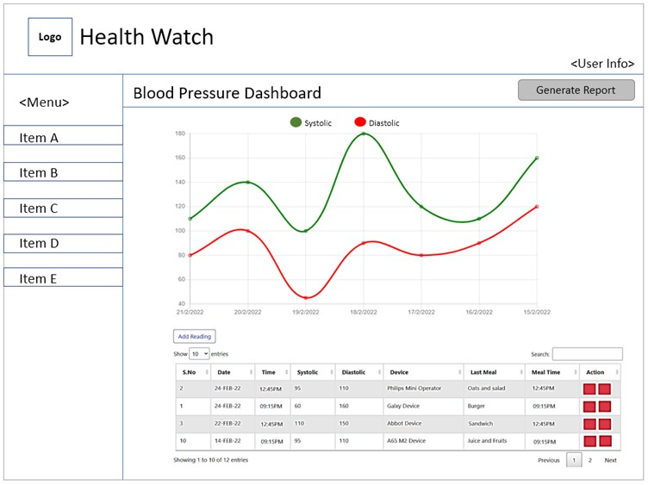

Figure 3.1.5 Wireframe for Blood Pressure/Glucose/Pulse/Respiration records addition
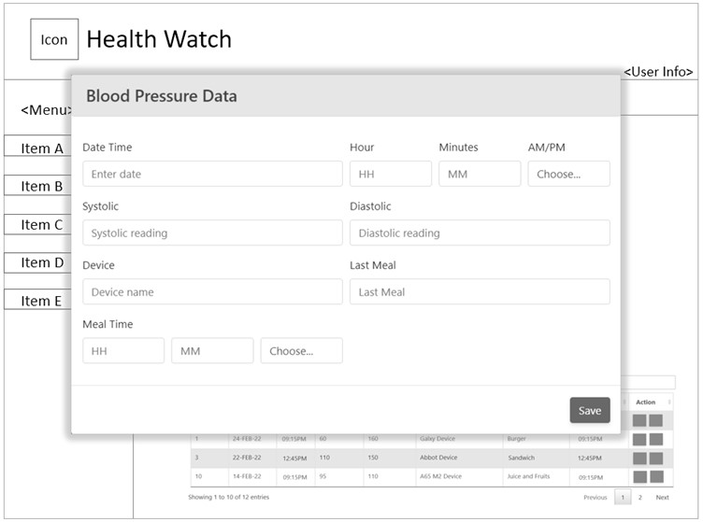

Figure 3.1.6 Wire frame for Blood Pressure & other’s report generation and printing
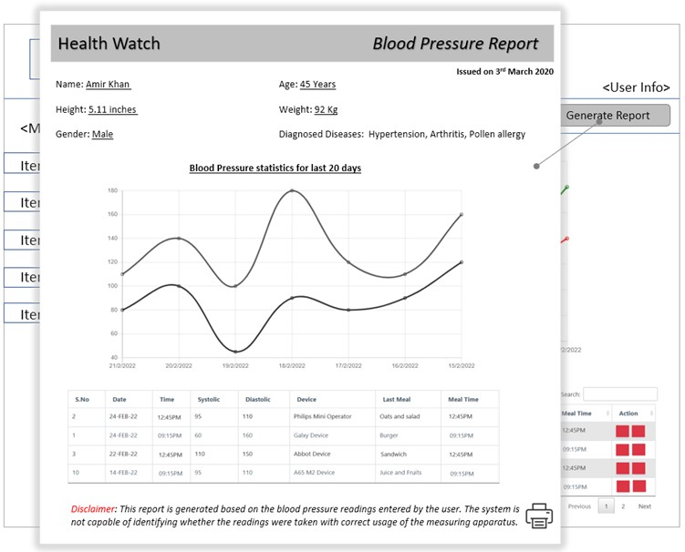

Figure 3.1.7 Wire frame for System Configuration/Settings update
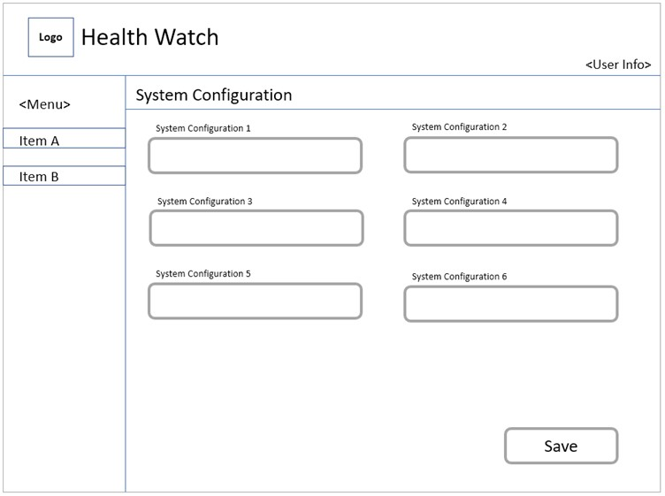

Hardware Interfaces
Client | Personal computer/tablets/smartphones with Internet access  Mobile phone
Web Server | Recommended 8GB RAM, 4 Core Processor  Windows 10 with Microsoft IIS Server, .net 6 runtime & Oracle Client
Database Server | Recommended 16GB RAM, 4 Core Processor  Oracle Database 21c Express Edition

Software Interfaces
The Health Watch system works by interfacing with its internal components as well an external component as depicted by the Component Diagram below.

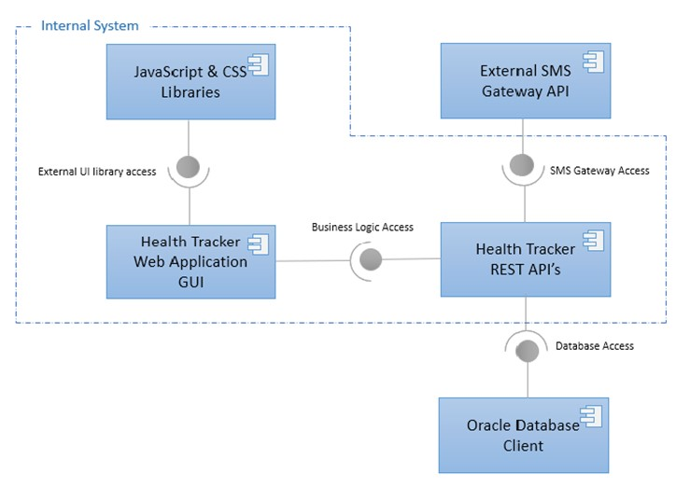

Communications Interfaces
- Browsers – W3C compliant with communication over HTTPS (TLS) enabled
- Mobile Phone – Non-smart phone with globally reachable carrier number
- Publicly accessible internal REST API end points
- Publicly accessible external gateway endpoint

Functional Requirements
The functional requirements are depicted as Use Cases and Sequence Diagrams as shown below

Use Cases
Possible interactions of user with the system
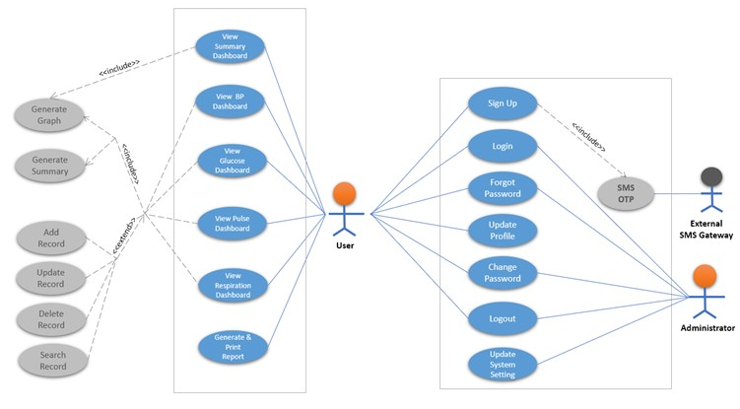

Use Case | UC01-Sign-Up
Business Actors | Visitor
Includes | SMS OTP
Extents | None
Description | Visitor can register with the system by providing its details and choosing an ID and password

Use Case | UC02-Login
Business Actors | User, Administrator
Includes | None
Extents | None
Description | A registered user/admin can Login using ID and password to access system resources

Use Case | UC03-SMS OTP
Business Actors | Visitor
Includes | None
Extents | None
Description | On visitors Sign-Up, external SMS gateway sends OTP in SMS to the visitor's mobile number

Use Case | UC04-Forgot Password
Business Actors | User, Administrator
Includes | None
Extents | None
Description | User/Administrator can reset a forgotten password by providing User Id

Use Case | UC05-Update Profile
Business Actors | Customer
Includes | None
Extents | None
Description | A logged in user can modify its profile data stored in the system

Use Case | UC06-Change Password
Business Actors | User, Administrator
Includes | None
Extents | None
Description | A logged in User/Administrator can change its existing password stored in the system

Use Case | UC07-Logout
Business Actors | User, Administrator
Includes | None
Extents | None
Description | Logged in User/Administrator can logout from the system to prevent further access from its account

Use Case | UC08-Update System Setting
Business Actors | Administrator
Includes | None
Extents | None
Description | Logged in Administrator can modify system settings

Use Case | UC09-View Summary Dashboard
Business Actors | User
Includes | Generate Graph
Extents | None
Description | Logged in user can view daily average-based graphs for BP, Glucose, Pulse and Respiration data in a single view

Use Case | UC10-Generate Graph
Business Actors | User
Includes | None
Extents | None
Description | Generate graph for BP, Glucose, Pulse and Respiration data

Use Case | UC11-View BP Dashboard, View Glucose Dashboard, View Pulse Dashboard, View Respiration Dashboard
Business Actors | User
Includes | Generate Graph, Generate Summary
Extents | Add Record, Update Record, Delete Record, Search Record
Description | A Logged in user can view summaries, table and graphs displayed in respective dashboards of  BP, Glucose, Pulse and Respiration and perform extended functionalities

Use Case(s) | UC12-Generate Summary
Business Actors | User
Includes | None
Extents | None
Description | Show summary for BP/Glucose/Pulse/Respiration data

Use Case | UC13-Add Record
Business Actors | User
Includes | None
Extents | None
Description | Logged in user can add records for BP/Glucose/Pulse/Respiration

Use Case(s) | UC14-Update Record
Business Actors | User
Includes | None
Extents | None
Description | Logged in user can modify records of BP/Glucose/Pulse/Respiration

Use Case(s) | UC15-Delete Record
Business Actors | User
Includes | None
Extents | None
Description | Logged in user can delete records of BP/Glucose/Pulse/Respiration

Use Case(s) | UC16-Search Record
Business Actors | User
Includes | None
Extents | None
Description | Logged in user can perform search on tabular data of BP, Glucose, Pulse or Respiration

Sequence Diagrams
Event(s): 1.0 Sign-Up,
2.5 Login
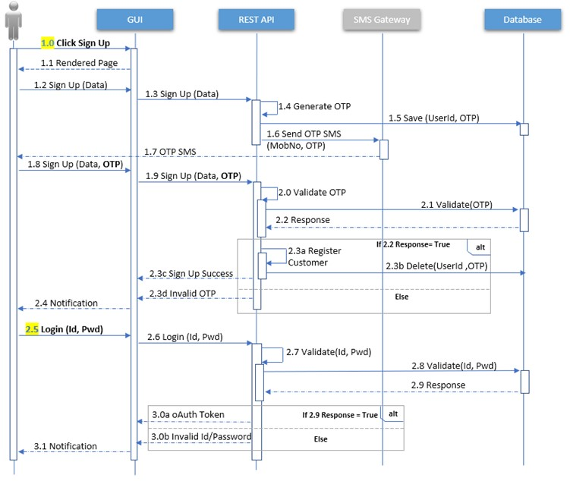

Event(s): 1.0 View Summary Dashboard,
1.7 View Blood Pressure, Glucose, Pulse and Respiration Dashboards
2.4 Add/Update/Delete data for Blood Pressure, Glucose, Pulse and Respiration
3.1, 3.8 Generate & Print Report

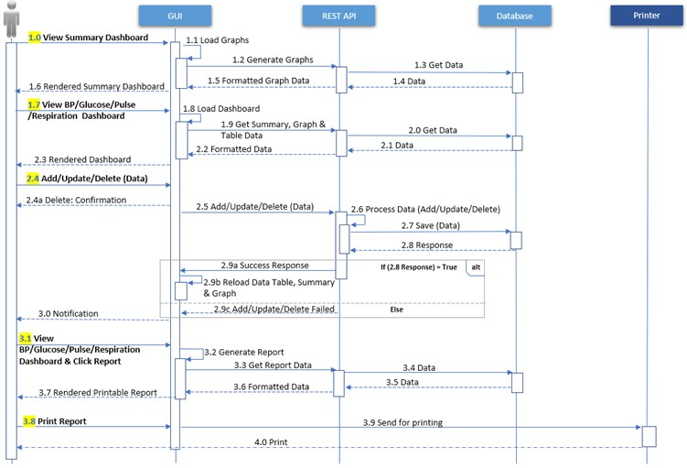

Event(s): 1.0, 1.8 View/Update Profile
2.4 Change Password

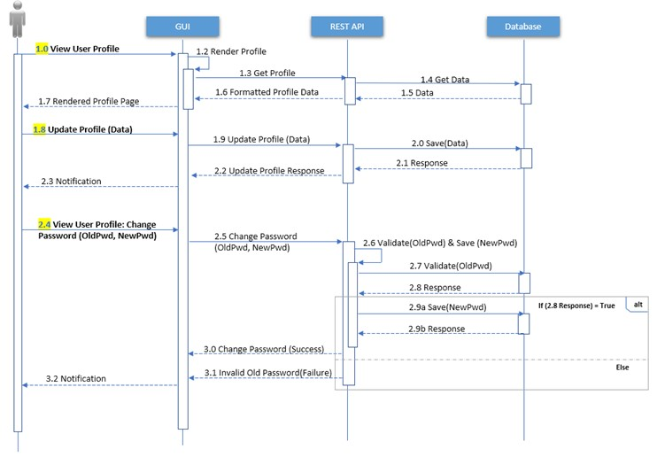

Events(s): 1.0 Forgot Password
2.1 Logout
2.4 Update system setting
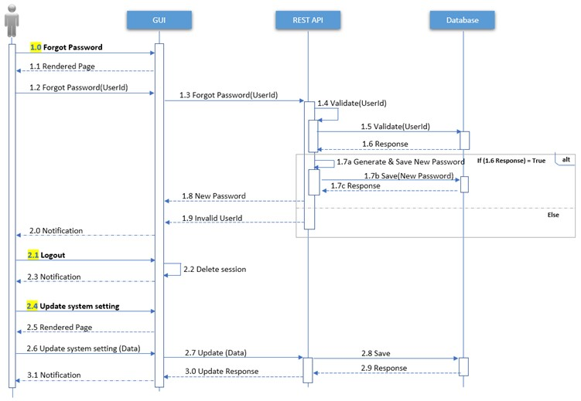

Other Nonfunctional Requirements

Usability
- System will be based on Minimalistic Web Design (Kate Moran 2015) to facilitate the most frequent user classes which is the senior age group class and the user class with low education or computer knowledge.

- Simple workflows and intuitive controls to make the system easy to learn.

- Responsiveness to cater different screen sizes

- Being a data intensive system, minimum required data should be requested from user to avoid time consuming workflows

Performance Requirements
- AJAX (Asynchronous JavaScript And XML) for rendering only the updated HTML objects rather than reloading the entire page (IBM 2021) for quick and seamless reload of graphs, summaries and data table after addition, updation or deletion of records.

- Database queries inside Stored Procedures for quick response time which is achieved from precompiled execution plans of stored procedures (ORACLE, n.d.).

Safety Requirements
Feeding incorrect health records will cause the system to generate incorrect statistics which can pose a serious health risk therefore, agreement on these terms & conditions should be a mandatory pre-requisite of Sign-Up process.

Security Requirements

Communication
- OTP verification to authenticate user during registration

- oAuth token-based authorization mechanism (oAuth.com, n.d.) to access REST API’s

- Encrypted client-server communication over HTTPS (TLS) protocol

5.4.2 Data
- Passwords or any other sensitive data to be stored encrypted in database

- Special characters validation to prevent SQL injection through GUI inputs

- Data in browser storages to be destroyed on session termination

Software Quality Attributes
QA (Quality Assurance) will be performed against Test-Cases covering different testing types (Vishal Sharma, n.d.) as listed below

Testing Type | Stage | Method | Objective
Unit | Development | Browser Developer Tools Postman API Client | Verify output of developed functions
Integration | Post-Development | Integration Test-Cases Run | Expected behavior of all interconnected components
Smoke | Pre-Sanity/Regression | Smoke Test-Cases Run | Ensure system is good for further testing
Sanity & Regression | Post-Development changes | Sanity & Regression Test-Cases Run | Verify functional stability
Compatibility | Post-Development | Verification against SRS | Verify cross-browser/device stability
Performance/Load Testing | Post-Development | Performance Test-Cases Run using JMeter | Ensure normal behavior under load
Acceptance Testing | Post-Development/Pre-delivery | Verification against SRS requirements | Ensure system is developed in compliance with the SRS
Pen Testing | Post-Development | Queries from https://pentest-tools.com/blog/sql-injection-attacks | SQL Injection through UI
Usability Testing | Post-Development | Usability Test-Cases Run | Measure user-friendliness

Appendix A: Analysis Models

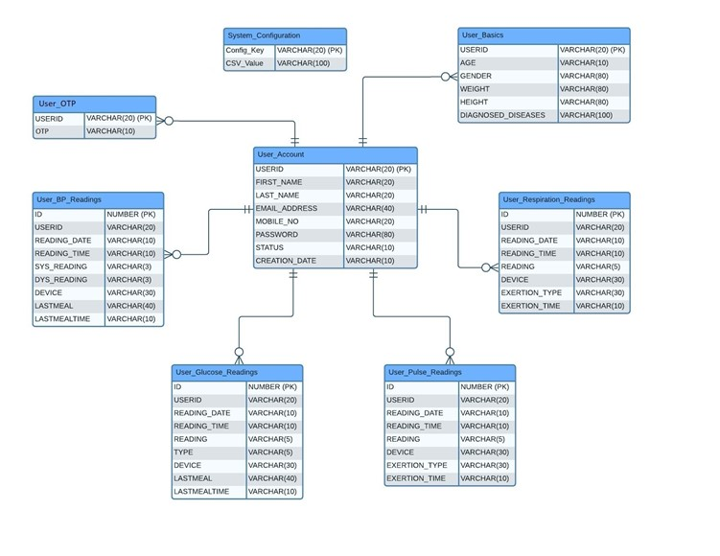
ERD (Entity Relationship Diagram)

